RAG Based Project

- Understanding Statement
- Introduction part

- This project implements a Retrieval-Augmented Generation (RAG) system that answers user questions based on educational video content. Instead of generating answers only from a language model's knowledge, the system first retrieves the most relevant information from video transcripts using semantic embeddings and then generates a contextual answer using a Large Language Model (LLM).

- The workflow begins by converting course videos into audio files, transcribing the audio into text, creating vector embeddings for each transcript chunk, and storing them efficiently. When a user asks a question, the system searches for the most relevant transcript chunks using cosine similarity and passes those chunks to the LLM, which generates an accurate answer along with the corresponding video timestamp.

- Technology Used
• Python
• FFmpeg
• OpenAI Whisper (Large-v2)
• BGE-M3 Embedding Model
• Ollama
• Llama 3.2
• Pandas
• NumPy
• Scikit-learn
• Joblib
• JSON
• Requests Library

- Raw information
- Video Link
- The dataset consists of HTML tutorial videos stored locally inside the tutorials/ directory.
- Each tutorial video acts as the knowledge source for the RAG system.
- https://youtu.be/iID14S3QPso?si=KWMmqaJrUpSQ9FCd
- Context of Video

- The videos explain HTML fundamentals including concepts, syntax, tags, and practical examples.
- The complete video content is converted into searchable text so users can ask natural language questions related to the course.

- How to Download

- Download the HTML tutorial videos from any sites.
- Save the videos inside the tutorials/ folder.
- Execute the FFmpeg conversion script.
- Audio files are generated inside the audios/ folder.
- The audio is transcribed into JSON transcripts using Whisper.
- Embeddings are generated and stored for semantic retrieval.

- Workflow
- Flow Diagram
- Collecting Data / Videos
- Educational HTML tutorial videos are collected and stored in the tutorials/ directory. These videos serve as the primary knowledge source for the RAG system.

- Converting Video into Audio
- FFmpeg is used to extract audio from every video automatically. Each video is converted into MP3 format so that it can be processed by the Whisper speech recognition model.
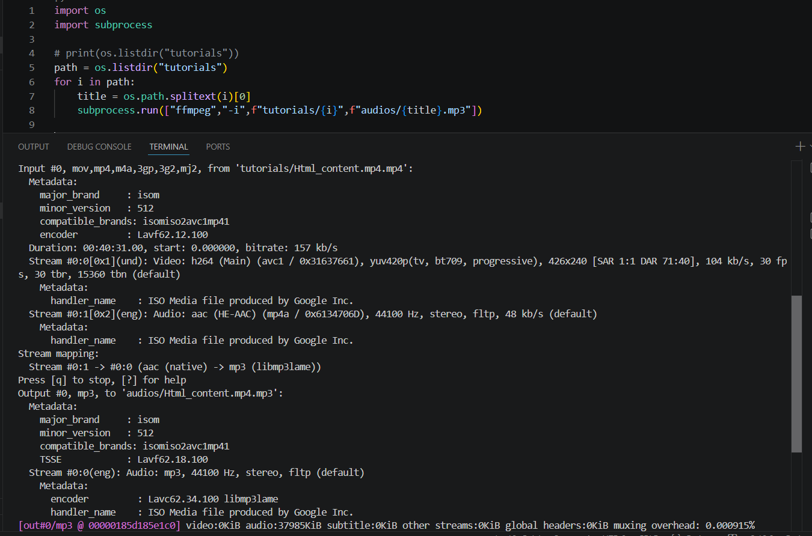

- Audio to Text
- The Whisper Large-v2 model transcribes each audio file into English text while preserving timestamp information.
- Each transcript is divided into multiple chunks containing:
• Video Title
• Chunk Number
• Start Time
• End Time
• Transcript Text
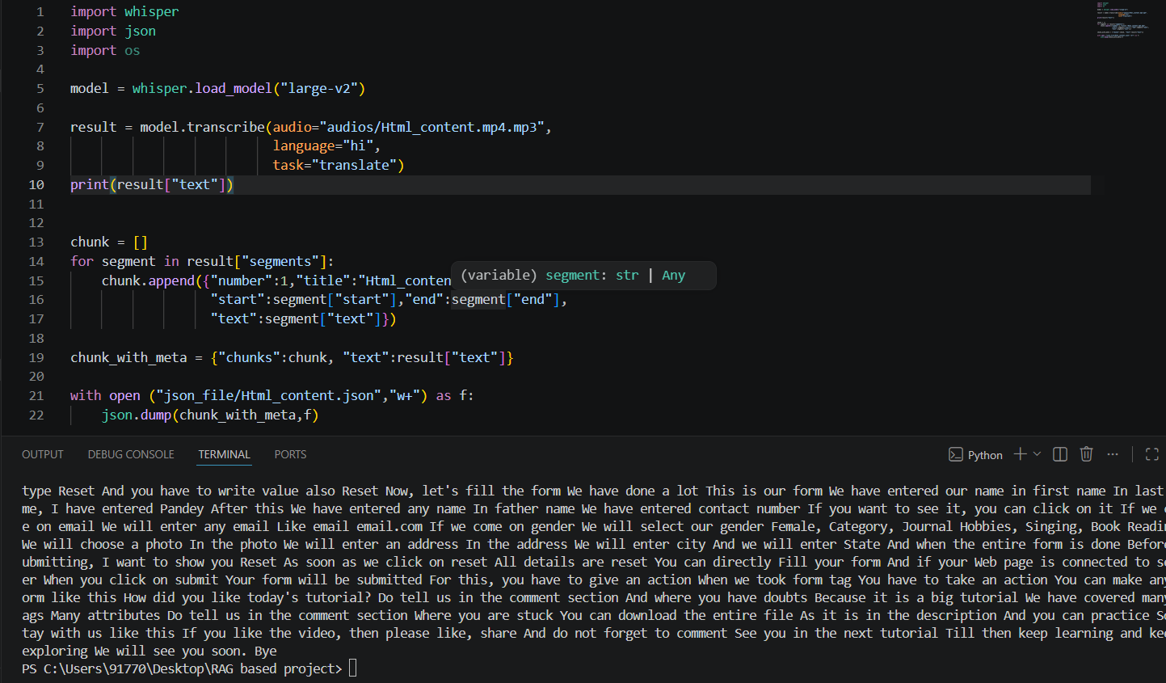

- Text to Embeddings
- Every transcript chunk is converted into dense vector embeddings using the BGE-M3 embedding model running through Ollama.
- These embeddings capture the semantic meaning of each transcript instead of simple keyword matching.
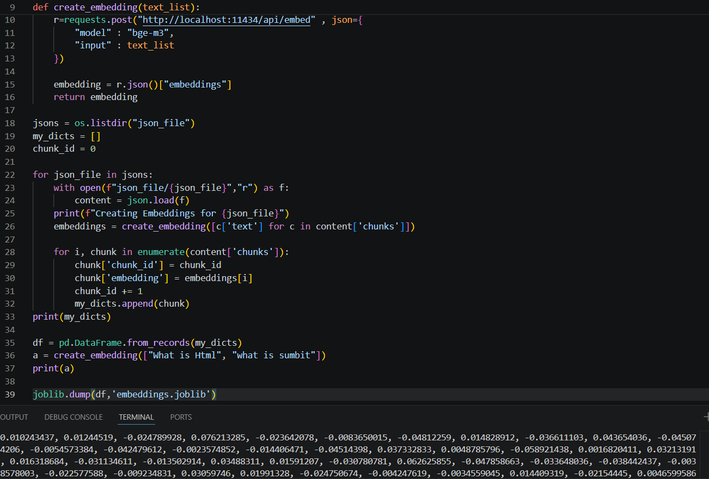

- Saving to Joblib/Pickle
- All transcript chunks along with their embeddings are stored inside a Pandas DataFrame.
- The DataFrame is serialized using Joblib for fast loading during inference.
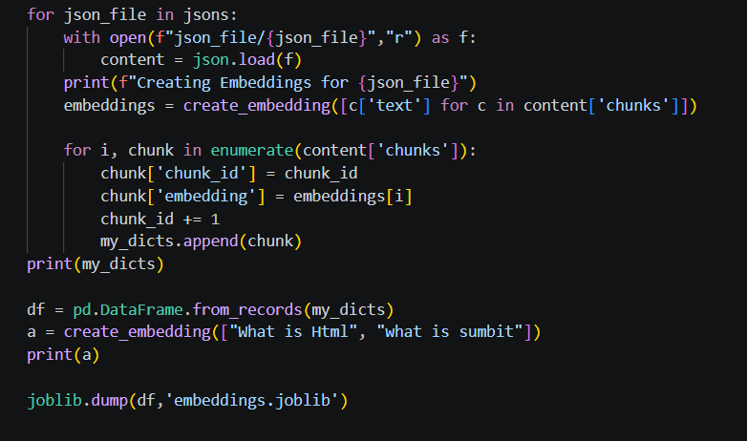
- Parsing / Reading Embeddings with Prompt
- The saved Joblib file is loaded.
- The user's question is converted into an embedding.
- Cosine similarity is calculated between the and every transcript embedding.
- The top five most relevant transcript chunks are selected.
- These chunks are inserted into a custom prompt for the Llama 3.2 model.

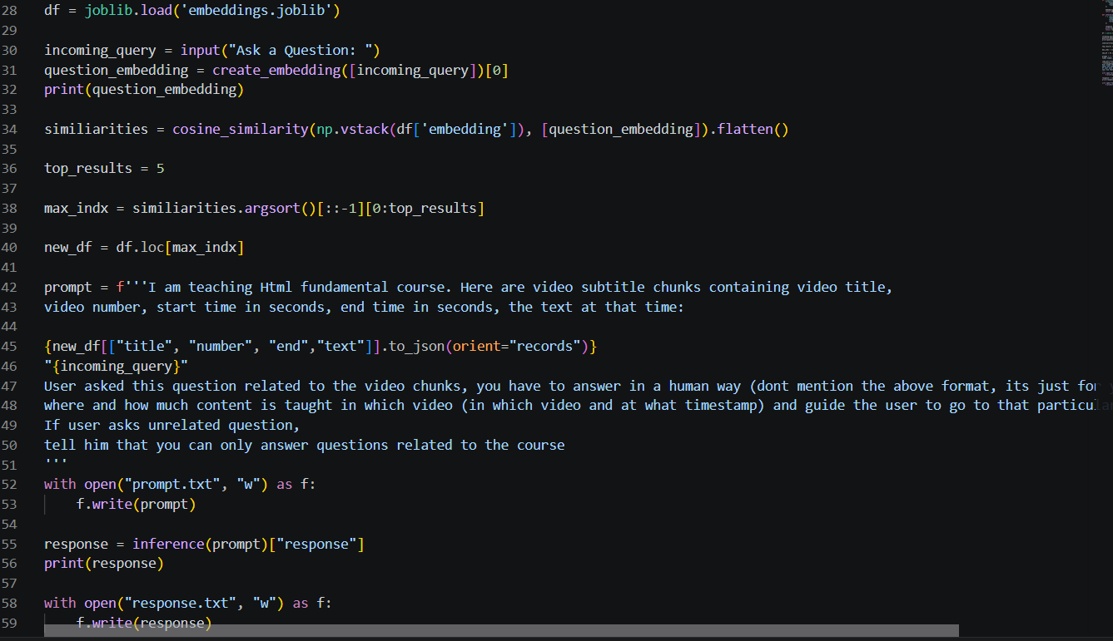

- Matching the Best Result
- The system ranks transcript chunks using cosine similarity.
- The five highest-scoring chunks are retrieved and provided as context to Llama 3.2.
- If the question is unrelated to the HTML course, the model politely informs the user that it can answer only course-related questions.

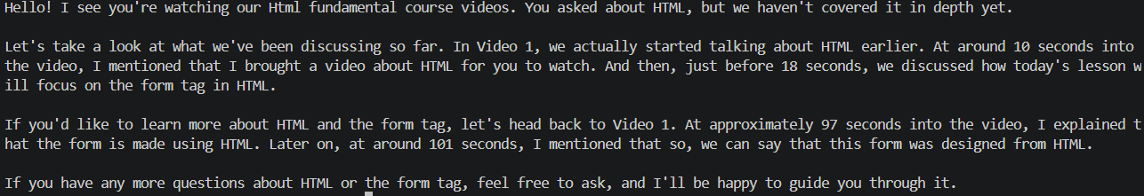

- Execution and Results
- Coding and Blocks
- FFmpeg Block
- This module automatically converts all tutorial videos into MP3 audio files using FFmpeg.
- The purpose of using FFmpeg is for Video preprocessing, Audio extraction,
Batch conversion.

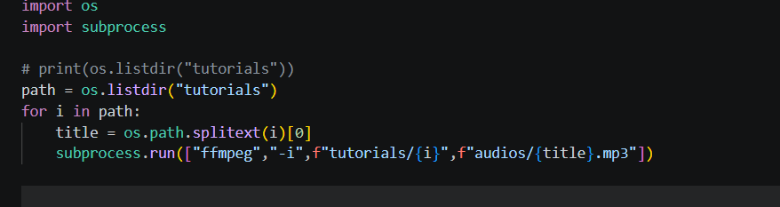

- Whisper Block
- This module loads the Whisper Large-v2 model and converts audio into timestamped text.
- The functions performed by the Whisper are Speed recognition, Translation, Transcript Generation and JASON Export.
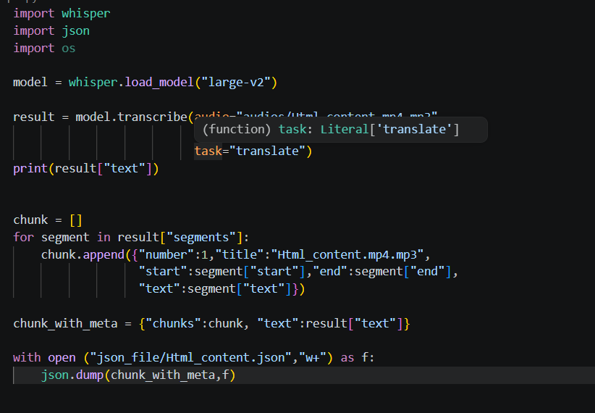

- Embeddings Block
- This module sends transcript chunks to the BGE-M3 embedding model using Ollama.
- The functions are Generate semantic embeddings, Assign unique chunk IDs, Save embeddings into a DataFrame, and Export using Joblib.

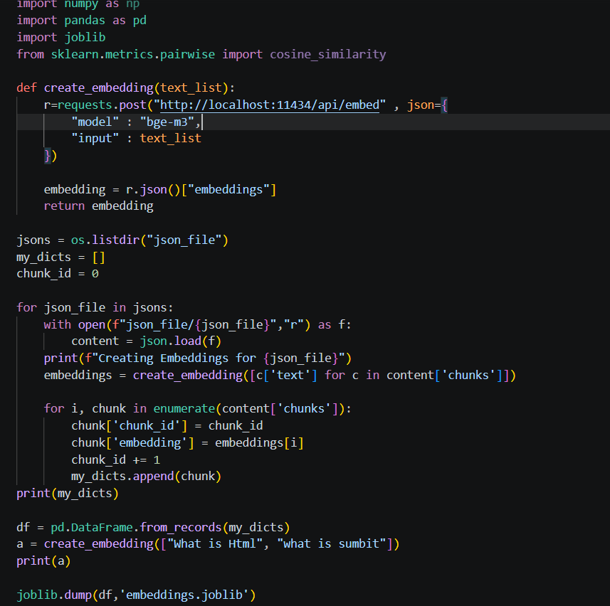

- Custom Function
The custom inference pipeline performs:
- User question embedding generation
- Cosine similarity calculation
- Top-5 chunk retrieval
- Prompt creation
- Llama 3.2 response generation
- Answer formatting with timestamps
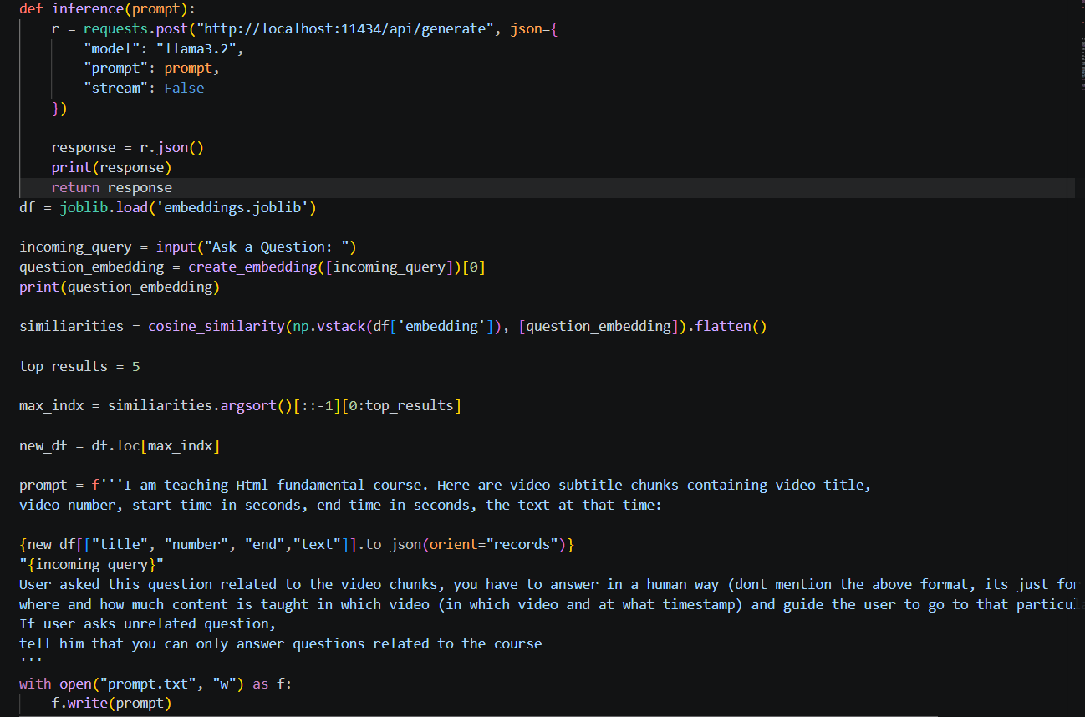

- Output
The system successfully:
- Converts videos into searchable knowledge.
- Retrieves semantically relevant transcript chunks.
- Generates accurate answers using Llama 3.2.
- Provides the exact video name and timestamp where the concept is explained.
- Restricts responses to course-related questions only.
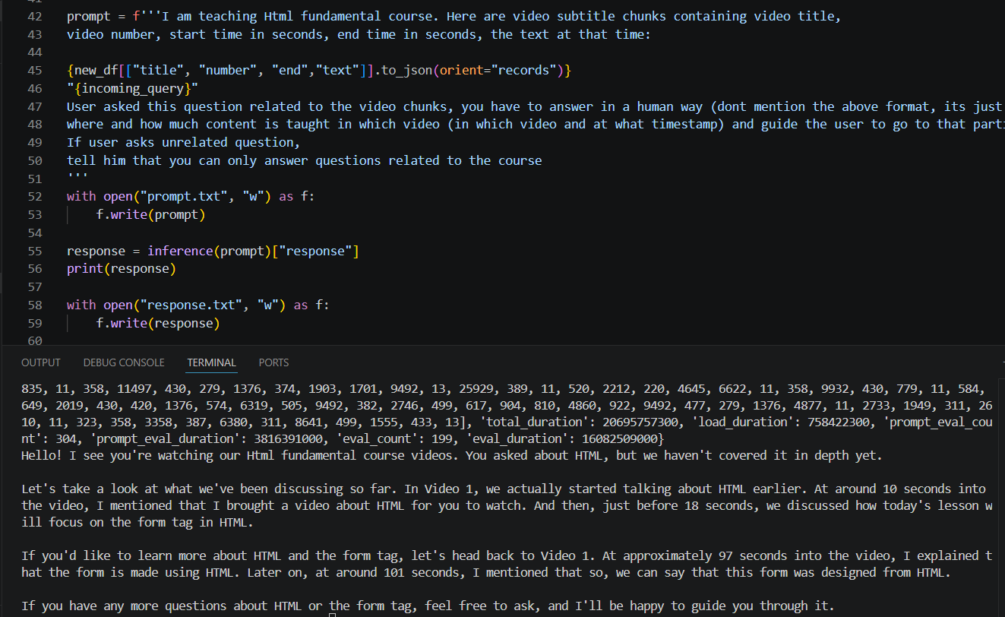

- Website Link
- Whisper : https://github.com/openai/whisper
- FFmpeg : https://www.ffmpeg.org/
- Ollama : https://ollama.com/
- BGE-M3 Model : https://huggingface.co/BAAI/bge-m3
- Joblib : https://joblib.readthedocs.io/en/stable/

- Conclusion

This project successfully demonstrates the implementation of a Retrieval-Augmented Generation (RAG) system for educational video question answering. By integrating FFmpeg, Whisper, BGE-M3 embeddings, cosine similarity, and the Llama 3.2 language model, the system retrieves relevant transcript information before generating responses. This approach improves answer accuracy while allowing users to locate the exact video and timestamp where a topic is explained.

